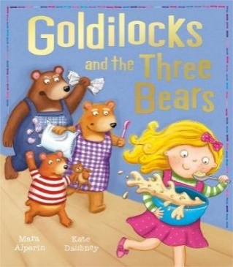

* Start by sharing the story if you have a copy of the book.

You could also watch and listen to the story by following this link: <https://oldhamtheatreworkshop.co.uk/story-festival-part-1/>

* Take turns at being one of the 3 bears and have fun doing the different voices as you tell the story.
* Baby Bear’s chair was broken. Talk about familiar items at home that have been broken. What happened? Could they be mended?
* Talk about how the characters feel (happy, excited, angry, shocked, upset, scared). You could give a choice of 2. When Baby Bear sees his broken chair you could say ‘Is Baby Bear happy or upset?’
* Help your child to understand the story. You could say ‘Goldilocks is eating the porridge because……’ (she’s hungry). ‘Daddy Bear is angry because…. ‘(the chair is broken). Give your child a few seconds thinking time then if they don’t know, tell them the answer.
* Talk about the people in your house or draw a picture of them. Who is the biggest/smallest?
* The 3 bears liked to eat porridge for breakfast. Talk about what the people in your house like for breakfast. Maybe you could try some porridge?
* Let your child help to make porridge. Talk about what you need to do at each step. Later, let your child play at pretending to make porridge. They could show their favourite teddy how to do it and talk them through each instruction with your help.
* Use words like *dry, runny, sloppy, sticky* when you are mixing your porridge.
* Talk about hot and cold food. What are the favourite hot & cold meals in your family?
* Following instructions while helping around the home: Say things like ‘Find me the biggest plate’ or ‘Give me the smallest sock’
* Have fun singing the 3 Bears song and joining in with the actions!

<https://www.youtube.com/watch?v=PFXE3zvXbjc>

* Use the language patterns from the story in your daily activities. You could say things like ‘This shoe is too big but this one is just right’ or ‘This towel is too wet but this one is just right’